**Spring MVC**

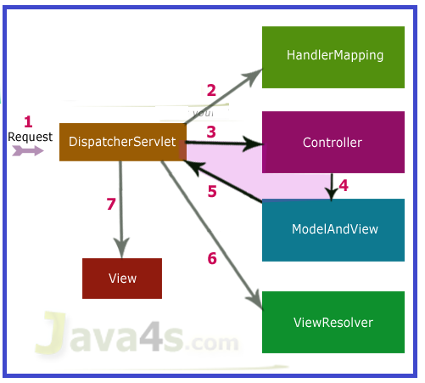

## Execution Flow

**Step 1:** First request will be received by DispatcherServlet  
**Step 2**: DispatcherServlet will take the help of HandlerMapping and get to know the Controller class name associated with the given request  
**Step 3**: So request transfer to the Controller, and then controller will process the request by executing appropriate methods and returns ModeAndView object (contains Model data and View name) back to the DispatcherServlet  
**Step 4**: Now DispatcherServlet send the model object to the ViewResolver to get the actual view page  
**Step 5**: Finally DispatcherServlet will pass the Model object to the View page to display the result

In Spring Web MVC, **DispatcherServlet** class works as the front controller.

It is responsible to manage the flow of the spring mvc application.

The **@Controller** annotation is used to mark the class as the controller in Spring 3.

The **@RequestMapping** annotation is used to map the request url. It is applied on the method.